Rab9A
Catalog Number: 21073

Gene Symbol: RAB9A
Description: Anti-Rab9A Rabbit Polyclonal Antibody

Background: Ras-related protein Rab-9A mediates late endosome to trans-Golgi transport. Recently Rab9 has been implicated as a key cellular component for human HIV, Ebola, Marburg, and measles virus replication.
Immunogen: A synthetic peptide from the C-terminal of human Rab9A protein
Tested applications: ELISA, WB, IHC, IP

Recommended dilutions:
ELISA 1:100-1:5000
WB 1:100-1:1000
IHC 1:50-1:100
Concentration: 0.2 mg/ml
Host: Rabbit
Clonality: Polyclonal Purity: Purified from serum Format: Liquid

Storage buffer:
Preservative: no
Constituents: PBS (without Mg²⁺ and Ca²⁺), pH 7.4, 150 mM NaCl, 50% glycerol
Species Reactivity: Rab9A antibody recognizes Rab9A proteins from vertebrates.
Storage Conditions: Store at -20°C. Avoid freeze
/ thaw cycles

Western blot:

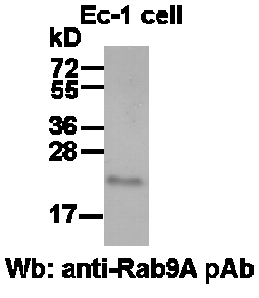

EC-1 whole-cell lysate was used for Western blot with anti-Rab9A polyclonal antibody (cat # 21073).

