Rab7A
Catalog Number: 21069

Gene Symbol: RAB7A
Description: Anti-Rab7A Rabbit Polyclonal Antibody

Background: Rab7A belongs to the Rab family of small GTPases. Rab7A is located in the late endosome, lysosome, cytoplasmic vesicle, phagosome and melanosome. It is involved in the late endocytic transport and contributes to the maturation of phagosomes.
Immunogen: A synthetic peptide near the C-terminus of Rab7A of human origin.
Tested applications: ELISA, WB, IHC, IP

Recommended dilutions:
ELISA 1:100-1:5000
WB 1:100-1:2000
IHC 1:10-1:100
Concentration: 0.2 mg/ml
Host: Rabbit
Clonality: Polyclonal Purity: Purified from serum Format: Liquid

Storage buffer:
Preservative: no
Constituents: PBS (without Mg²⁺ and Ca²⁺), pH 7.4, 150 mM NaCl, 50% glycerol
Species Reactivity: Rab7A antibody recognizes Rab7A from vertebrates.
Storage Conditions: Store at -20°C. Avoid freeze / thaw cycles

Western blot:

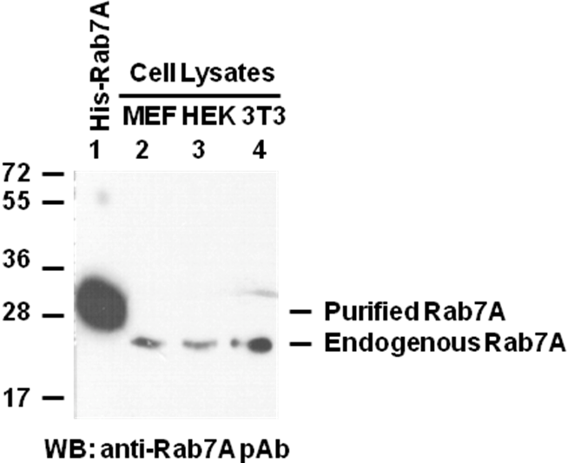

Purified recombinant His-tagged Rab7A protein (lane 1, Cat # 10167), MEF (lane 2), HEK293
(lane 3) and NIH 3T3 (lane 4) cell lysates were used for Western blot with anti-Rab7A polyclonal antibody (Cat # 21069).

