

Rab5C
Catalog Number: 21038
Gene Symbol: RAB5C
Description: Anti-Rab5C Rabbit Polyclonal Antibody

Background: Rab5, consists of three isoforms, Rab5A, Rab5B, and Rab5C, is a small GTPase that is localized to early endosomes. It regulates the fusion between endocytic vesicles and early endosomes, as well as the homotypic fusion between early endosomes.
Immunogen: A synthetic peptide from Rab5C Tested applications: ELISA, WB, IHC Recommended dilutions:
ELISA 1:100-1:5000
WB 1:100-1:1000
IHC 1:100-1000
Concentration: 0.2 mg/ml
Host: Rabbit
Clonality: Polyclonal Purity: Purified from serum Format: Liquid
Storage buffer:
Preservative: no
Constituents: PBS (without Mg²⁺ and Ca²⁺), pH 7.4, 150 mM NaCl, 50% glycerol
Species Reactivity: Rab5C antibody recognizes Rab5C from vertebrates.
Storage Conditions: Store at -20°C. Avoid freeze
/ thaw cycles
Western blot:

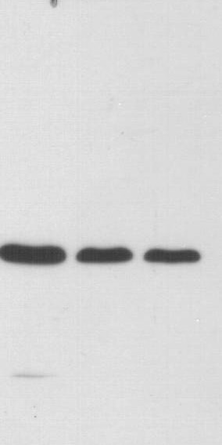
KD 55

123
36
28

17

WB: anti-Rab5C pAb

EC-1 (lane 1) , HEK-293T (lane 2) and MEF (lane
3) cell lysates were used for Western blot with anti-Rab5C polyclonal antibody (cat # 21038).

For research use only. Not for diagnostic or therapeutic applications.

24 Whitewoods Lane, Malvern, PA 19355 Tel: (610) 945-2007 Fax: (610) 945-2008 E-mail: sale@neweastbio.com Web: www.neweastbio.com

