Rab5
Catalog Number: 21151

Gene Symbol: RAB5
Description: Anti-Rab5 Rabbit Polyclonal Antibody

Background: Rab5, consists of three isoforms, Rab5A, Rab5B, and Rab5C, is a small GTPase that is localized to early endosomes. It regulates the fusion between endocytic vesicles and early endosomes, as well as the homotypic fusion between early endosomes.
Immunogen: Three synthetic peptides from the internal region of human Rab5A , Rab5B and Rab5C proteins, respectively
Tested applications: ELISA, WB, IHC, IP

Recommended dilutions:
ELISA 1:100-1:5000
WB 1:100-1:2000
IHC 1:100-1000
Concentration: 0.2 mg/ml
Host: Rabbit
Clonality: Polyclonal Purity: Purified from serum Format: Liquid

Storage buffer:
Preservative: no
Constituents: PBS (without Mg²⁺ and Ca²⁺), pH 7.4, 150 mM NaCl, 50% glycerol
Species Reactivity: Rab5 antibody recognizes Rab5A, Rab5B and Rab5C from vertebrates. Storage Conditions: Store at -20°C. Avoid freeze

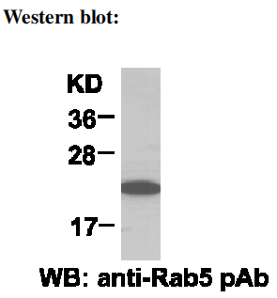

HEK-293T cell lysate was used for Western blot with anti-Rab5 polyclonal antibody (cat # 21151).

/ thaw cycles

