Rab41
Catalog Number: 21084

Gene Symbol: RAB41
Description: Anti-Rab41 Rabbit Polyclonal Antibody

Background: Rab GTPases are Ras-like small molecular weight GTP binding proteins that are involved in various steps along the exocytic and endocytic pathways. Rab41 is widely expressed in brain, testis, lung, heart, ovary, colon, kidney, uterus and spleen.
Immunogen: A synthetic peptide from the N-terminal region of human Rab41 protein
Tested applications: ELISA, WB, IHC, IP

Recommended dilutions:
ELISA 1:100-1:5000
WB 1:100-1:1000
IHC 1:10-1:500
Concentration: 0.2 mg/ml
Host: Rabbit
Clonality: Polyclonal Purity: Purified from serum Format: Liquid

Storage buffer:
Preservative: no
Constituents: PBS (without Mg²⁺ and Ca²⁺), pH 7.4, 150 mM NaCl, 50% glycerol
Species Reactivity: Rab41 antibody recognizes Rab41 proteins from vertebrates.
Storage Conditions: Store at -20°C. Avoid freeze / thaw cycles

Western blot:

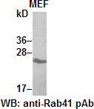

MEF whole-cell lysate was used for Western blot with anti-Rab41 polyclonal antibody (cat # 21084).

Immunohistochemistry:
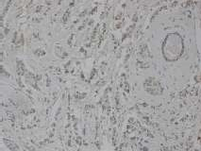
Immunohistochemical staining of formalin-fixed paraffin-embedded breast carcinoma using the affinitty purified anti-Rab41 polyclonal antibody (Cat # 21084) with 1:50 dilution.

