Rab39
Catalog Number: 21082

Gene Symbol: RAB39
Description: Anti-Rab39 Rabbit Polyclonal Antibody

Background: Ras-related protein Rab39 is a Golgi-associated protein involved in endocytosis. Immunogen: A synthetic peptide from the internal region of human Rab39 protein
Tested applications: ELISA, WB, IHC, IP

Recommended dilutions:
ELISA 1:100-1:5000
WB 1:100-1:1000
IHC 1:100-1:1000
Concentration: 0.2 mg/ml
Host: Rabbit
Clonality: Polyclonal Purity: Purified from serum Format: Liquid

Storage buffer:
Preservative: no
Constituents: PBS (without Mg²⁺ and Ca²⁺), pH 7.4, 150 mM NaCl, 50% glycerol
Species Reactivity: Rab39 antibody recognizes Rab39 proteins from vertebrates.
Storage Conditions: Store at -20°C. Avoid freeze / thaw cycles

Western blot:
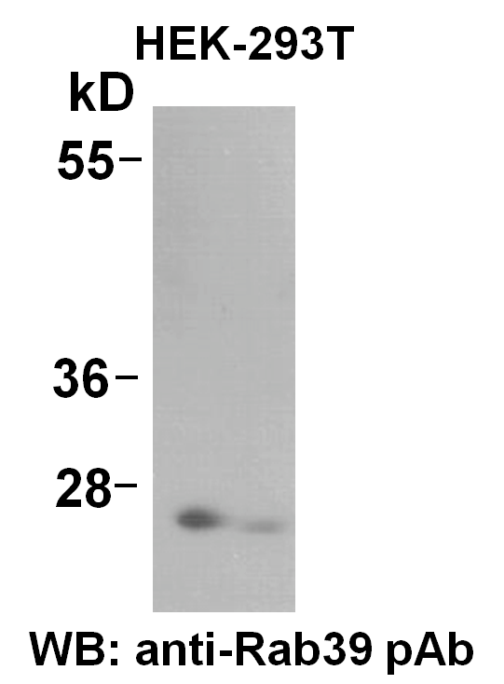

HEK-293T whole-cell lysate was used for Western blot with anti-Rab39 polyclonal antibody (cat # 21082).

