Rab18
Catalog Number: 21050

Gene Symbol: RAB18
Description: Anti-Rab18 Rabbit Polyclonal Antibody

Background: Rab18 is a member of the Ras-related small GTPases. Rab18 plays a role in apical endocytosis/recycling.
Immunogen: A synthetic peptide from the C-terminal end of huamn Rab18 protein Tested applications: ELISA, WB, IHC Recommended dilutions:
ELISA 1:100-1:5000
WB 1:100-1:1000
IHC 1:100-1:1000
Concentration: 0.2 mg/ml
Host: Rabbit
Clonality: Polyclonal Purity: Purified from serum Format: Liquid

Storage buffer:
Preservative: no
Constituents: PBS (without Mg²⁺ and Ca²⁺), pH 7.4, 150 mM NaCl, 50% glycerol
Species Reactivity: Rab18 antibody recognizes Rab18 proteins from vertebrates.
Storage Conditions: Store at -20°C. Avoid freeze / thaw cycles

Western blot:


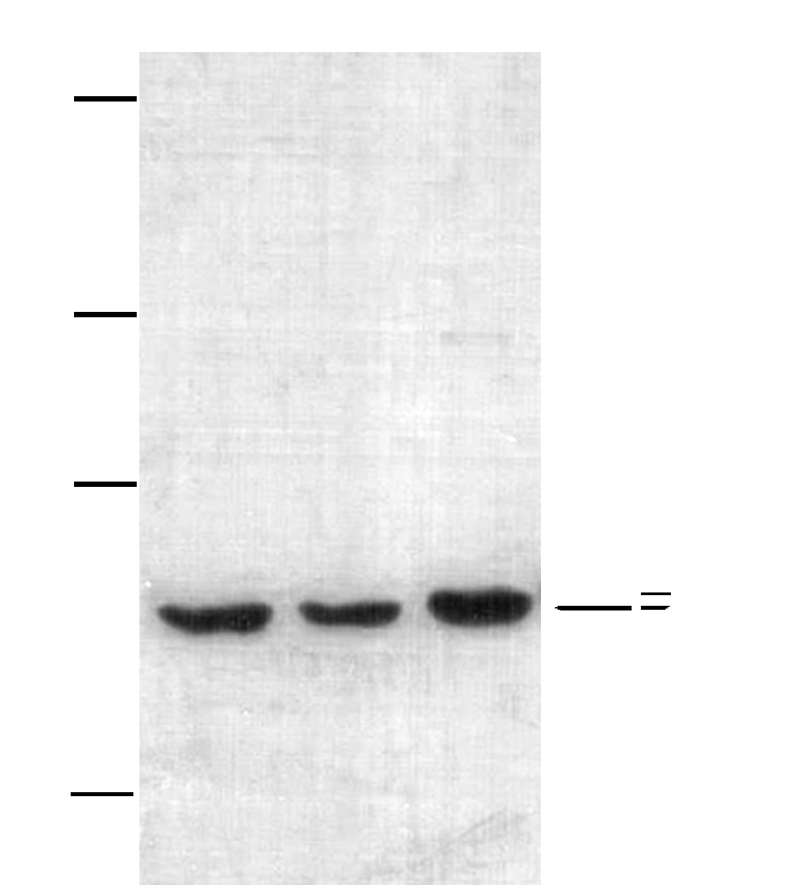


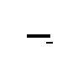

EC-1 (lane 1) , HepG (lane 2) and HEK-293T (lane 3) whole-cell lysates were used for Western blots with anti-Rab18 polyclonal antibody (cat # 21050).

