GRB7
Catalog Number: 21218

Gene Symbol: GRB7
Description: Anti-GRB7 Rabbit Polyclonal Antibody

Background: Grb7 is an adaptor protein that interacts with epidermal growth factor receptor (EGFR) and ephrin receptors. It plays a role in the integrin signaling pathway and cell migration by binding with focal adhesion kinase (FAK). Grb7 gene is commonly co-amplified (present in excess copies) in breast cancers. Grb7 is over-expressed in testicular germ cell tumors, esophageal cancers, and gastric cancers. There are clues that it involved in cell migration and metastatic progression of human esophageal carcinomas.
Immunogen: A synthetic peptide from the C-terminus of GRB7 protein, human origin.
Tested applications: ELISA, WB, IHC

Recommended dilutions:
ELISA 1:1000-1:5000
WB 1:250-1:2000
IHC 1:100-1000
Concentration: 0.5 mg/ml
Host: Rabbit
Clonality: Polyclonal Purity: Purified from serum Format: Liquid Preservative: no
Constituents: PBS (without Mg²⁺ and Ca²⁺), pH 7.4, 150 mM NaCl, 50% glycerol
Species Reactivity: Anti-GRB7 rabbit polyclonal antibody recognizes GRB7 from vertebrates.
Storage Conditions: Store at -20°C. Avoid freeze / thaw cycles

Western blot:
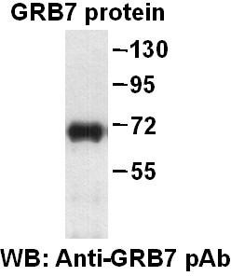
Western blot analysis of recombinant full length GRB7 protein. Purified His-tagged GRB7 protein was blotted with anti-GRB7 rabbit polyclonal antibody (Cat. # 21218).

