Gα_{z}
Catalog Number: 21016

Gene Symbol: GNAZ
Description: Anti-Gα_{z} Rabbit Polyclonal Antibody

Background: Heterotrimeric G proteins are critical cellular signal transducers. Gα_{z} belongs to the G_{i} sub-family of G proteins that could mediate the inhibition of adenylyl cyclases.
Other biochemical and physiological functions of Gα_{z} proteins are being explored.
Immunogen: Recombinant full length protein of Gα_{z}.
Tested applications: ELISA, WB, IHC

Recommended dilutions:
ELISA 1:100-1:5000
WB 1:100-1:2000
Concentration: 1 mg/ml
Host: Rabbit
Clonality: Polyclonal Purity: Purified from serum Format: Liquid

Storage buffer:
Preservative: no
Constituents: PBS (without Mg²⁺ and Ca²⁺), pH 7.4, 150 mM NaCl, 50% glycerol
Species Reactivity: Gα_{z} antibody recognizes Gα_{z} of vertebrates.
Storage Conditions: Store at -20°C. Avoid freeze / thaw cycles

Western blot:

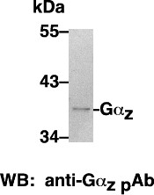

Western blot analysis of Gα_{z} proteins.
HEK-293 whole-cell lysate was used for western blots.

