Ga_{q}
Catalog Number: 21014
Gene Symbol: Gnaq
Description: Anti-Gα_{q} Rabbit Polyclonal Antibody

Background: Heterotrimeric G proteins are essential cellular signal transducers. Gα_{q} is a member of the Gq subfamily of G proteins. Gα_{q} is known to stimulate phospholipase C.
Other biochemical and physiological functions of Gα_{q} are being explored.
Immunogen: A synthetic peptide from a unique region of Gα_{q} protein
Tested applications: ELISA, WB, IHC

Recommended dilutions:
ELISA 1:100-1:5000,
WB 1:100-1:2000,
Concentration: 1 mg/ml
Host: Rabbit
Clonality: Polyclonal Purity : Purified from serum Format: Liquid

Storage buffer:
Preservative: no
Constituents: PBS (without Mg²⁺ and Ca²⁺), pH 7.4, 150 mM NaCl, 50% glycerol
Species Reactivity: Gα_{q} polyclonal antibody recognizes Gα_{q} of vertebrates.
Storage Conditions: Store at -20°C. Avoid freeze / thaw cycles

Western blot:

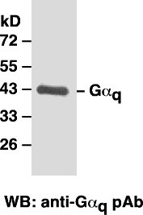

Western blot analysis of Gα_{q} proteins. MEF whole-cell lysates were used for western blot with anti- Gα_{q} polyclonal antibody (cat # 21014).

