Gα_{o}
Catalog Number: 21015
Gene Symbol: Gnao
Description: Anti-Gα_{o} Rabbit Polyclonal Antibody

Background: Heterotrimeric G proteins are critical cellular signal transducers. Gα_{o} belongs to the G_{i} sub-family of G proteins that could mediate the inhibition of adenylyl cyclases. Other biochemical and physiological functions of Gα_{o} proteins are being explored.
Immunogen: Recombinant full length protein of Gα_{o}
Tested applications: ELISA, WB, IHC

Recommended dilutions:
ELISA 1:1000-1:5000
WB 1:500-1:2000
Concentration: 1 mg/ml
Host: rabbit
Clonality: Polyclonal Purity: Purified from serum Format: Liquid

Storage buffer:
Preservative: no
Constituents: PBS (without Mg²⁺ and Ca²⁺), pH 7.4, 150 mM NaCl, 50% glycerol
Species Reactivity: Gα_{o} antibody recognizes Gα_{o} of vertebrates.
Storage Conditions: Store at -20°C. Avoid freeze / thaw cycles

Western blot:
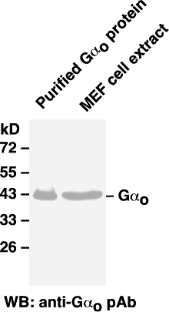

Western blot analysis of G_{o} proteins.
Whole-cell lysate of MEF cells or purified Gα_{o} protein were used for western blots with the polyclonal anti- Gα_{o} antibody (Cat # 21015).

