Gα_{i}
Catalog Number: 21006
Gene Symbol: Gnai
Description: Anti-Gα_{i} Rabbit Polyclonal Antibody

Background: Heterotrimeric G proteins are critical cellular signal transducers. Gα_{i} represents one sub-family of G proteins that could mediate the inhibition of adenylyl cyclases. Other biochemical and physiological functions of Gα_{i} proteins are being explored.
Immunogen: Recombinant full length protein of Gα_{i1}
Tested applications: ELISA, WB, IHC

Recommended dilutions:
ELISA 1:100-1:5000,
WB 1:100-1:2000,
Concentration: 1 mg/ml
Host: Rabbit
Clonality: Polyclonal Purity: Purified from serum Format: Liquid

Storage buffer:
Preservative: no
Constituents: PBS (without Mg²⁺ and Ca²⁺), pH 7.4, 150 mM NaCl, 50% glycerol
Species Reactivity: Gα_{i} antibody recognizes Gα_{i1}, Gα_{i2}, and Gα_{i3} of vertebrates.
Storage Conditions: Store at -20°C. Avoid freeze / thaw cycles

Western blot:

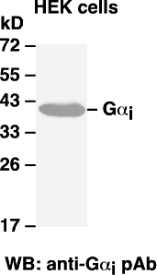

Western blot analysis of G_{i} proteins. Gα_{i1} plasmid DNA was transiently transfected into HEK-293 cells. Whole-cell lysate was used for western blot with the polyclonal anti- Gα_{i} antibody (cat # 21006).

