Gα₁₃
Catalog Number: 21005
Gene Symbol: Gna13
Description: Anti-Gα₁₃ Rabbit Polyclonal Antibody

Background: Heterotrimeric G proteins are essential cellular signal transducers. Gα₁₃ is one of the G proteins that could mediate cell migration and angiogenesis. Other biochemical and physiological functions of Gα₁₃ are being explored.
Immunogen: Recombinant full length Gα₁₃ protein
Tested applications: ELISA, WB, IHC

Recommended dilutions:
ELISA 1:100-1:5000
WB 1:100-1:2000
IHC 1:50-1:100
Concentration: 1 mg/ml
Host: Rabbit
Clonality: Polyclonal Purity: Purified from serum Format: Liquid

Storage buffer:
Preservative: no
Constituents: PBS (without Mg²⁺ and Ca²⁺), pH 7.4, 150 mM NaCl, 50% glycerol
Species Reactivity: Gα₁₃ polyclonal antibody recognizes Gα₁₃ of vertebrates.
Storage Conditions: Store at -20°C. Avoid freeze / thaw cycles

Western blot:
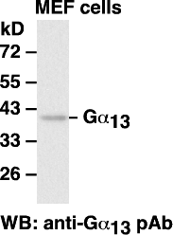

Western blot analysis of Gα₁₃ proteins. MEF whole-cell lysates were used for western blot with anti- Gα₁₃ polyclonal antibody (cat # 21005).

Immunofluorescence:

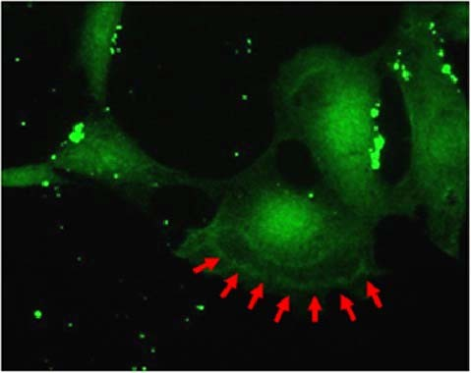
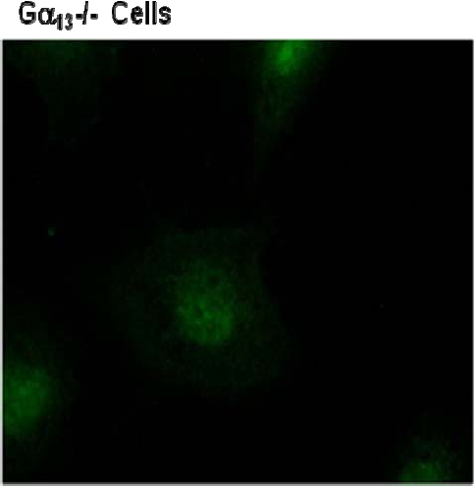
Immunofluorescence of mouse embryonic fibroblast (MEF) cells. Wild-type MEF cells (top panel) and Gα13 double knock-out cells (Gα13 -/-, bottom panel) were fixed and stained with anti-Gα13 polyclonal antibody (Cat. # 21005). Arrows indicate the dorsal ruffle strcture of one cell.

