Gα₁₂
Catalog Number: 21013
Gene Symbol: Gna12
Description: Anti-Gα₁₂ Rabbit Polyclonal Antibody

Background: Heterotrimeric G proteins are essential cellular signal transducers. Gα₁₂ is a member of the G_{12/13} subfamily of G proteins. Biochemical and physiological functions of Gα₁₂ are being explored.
Immunogen: Recombinant full length Gα₁₂ protein
Tested applications: ELISA, WB, IHC

Recommended dilutions:
ELISA 1:100-1:5000,
WB 1:100-1:2000,
Concentration: 1 mg/ml
Host: Rabbit
Clonality: Polyclonal Purity : Purified from serum Format: Liquid

Storage buffer:
Preservative: no
Constituents: PBS (without Mg²⁺ and Ca²⁺), pH 7.4, 150 mM NaCl, 50% glycerol
Species Reactivity: Gα₁₂ polyclonal antibody recognizes Gα₁₂ of vertebrates.
Storage Conditions: Store at -20°C. Avoid freeze / thaw cycles

Western blot:
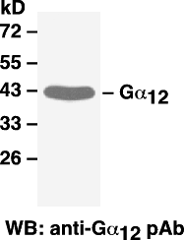

Western blot analysis of Gα₁₂ proteins. MEF whole-cell lysates were used for western blot with anti- Gα₁₂ polyclonal antibody (cat # 21013).

