Cdc42
Catalog Number: 21010

Gene Symbol: CDC42
Description: Anti-Cdc42 Rabbit Polyclonal Antibody

Background: Small GTPases are a super-family of cellular signaling regulators. Cdc42 belongs to the Rho sub-family of GTPases that regulate cell motility, cell division, and gene transcription.
GTP binding increases the activity of Cdc42, and the hydrolysis of GTP to GDP renders it inactive. GTP hydrolysis is aided by GTPase activating proteins (GAPs), while exchange of GDP for GTP is facilitated by guanine nucleotide exchange factors (GEFs).
Immunogen: A synthetic peptide from a unique region of Cdc42
Tested applications: ELISA, WB, IHC

Recommended dilutions:
ELISA 1:100-1:5000
WB 1:100-1:2000
IHC 1:50-1:100
Concentration: 0.2 mg/ml
Host: Rabbit
Clonality: Polyclonal Purity: Purified from serum Format: Liquid

Storage buffer:
Preservative: no
Constituents: PBS (without Mg²⁺ and Ca²⁺), pH 7.4, 150 mM NaCl, 50% glycerol
Species Reactivity: Cdc42 antibody recognizes Cdc42 from vertebrates.
Storage Conditions: Store at -20°C. Avoid freeze / thaw cycles

Western blot:
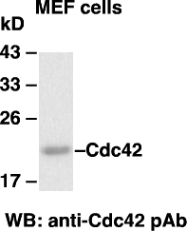

Western blot analysis of Cdc42 proteins. MEF whole-cell lysate was used for western blot with the polyclonal anti-Cdc42 antibody (cat. #21010).

