Cdc42
Catalog Number: 21019

Gene Symbol: CDC42
Description: Anti-Cdc42 Chicken Polyclonal Antibody

Background: Small GTPases are a super-family of cellular signaling regulators. Cdc42 belongs to the Rho sub-family of GTPases that regulate cell motility, cell division, and gene transcription. GTP binding increases the activity of Cdc42, and the hydrolysis of GTP to GDP renders it inactive. GTP hydrolysis is aided by GTPase activating proteins (GAPs), while exchange of GDP for GTP is facilitated by guanine nucleotide exchange factors (GEFs).
Immunogen: Recombinant full length Cdc42 protein
Tested applications: ELISA, WB, IHC

Recommended dilutions:
ELISA 1:100-1:5000
WB 1:100-1:1000
IHC 1:100-1:1000
Concentration: 1 mg/ml Host: Chicken Clonality: Polyclonal Isotype: IgY
Purity: Purified from egg yolk
Format: Liquid

Storage buffer:
Preservative: no
Constituents: PBS (without Mg²⁺ and Ca²⁺), pH 7.4, 150 mM NaCl, 50% glycerol
Species Reactivity: Cdc42 antibody recognizes Cdc42 from vertebrates.
Storage Conditions: Store at -20°C. Avoid freeze / thaw cycles

Western blot:


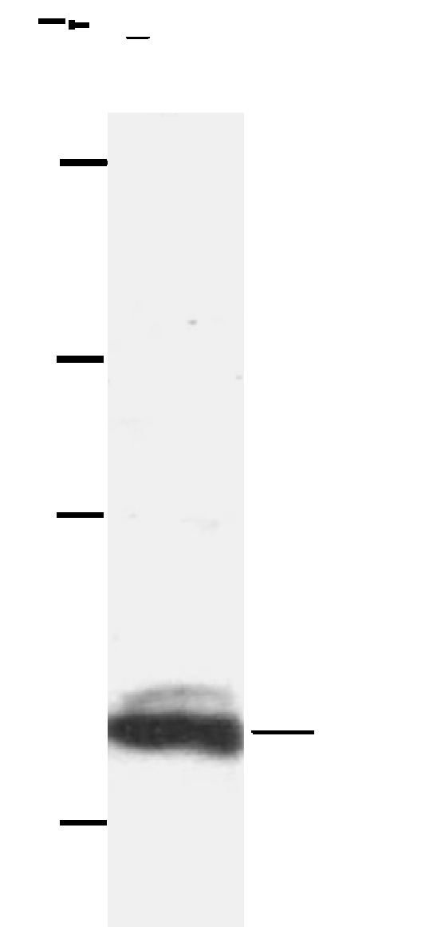



Western blot analysis of Cdc42 proteins. HepG whole-cell lysate was used for Western blot with the chicken polyclonal anti-Cdc42 antibody (cat # 21019).

