SLC7A5
Catalog Number: 21118
Gene Symbol: SLC7A5
Description: Anti- SLC7A5 Rabbit Polyclonal Antibody

Background: Solute carrier family 7 member 5 (also known as large neutral amino acids transporter small subunit 1) is a protein encoded by the SLC7A5 gene in human. SLC7A5 plays a role in neuronal cell proliferation, is involved in the uptake of methylmercury (MeHg) and plays a role in metal ion homeostasis and toxicity.

Immunogen: A synthetic peptide from the internal region of SLC7A5 of human origin.
Tested applications: ELISA, WB, IHC, IP

Recommended dilutions:
ELISA: 1:1000-1:5000
WB: 1:100-1:1000
IHC: 1:50-1:100
Concentration: 0.25 mg/ml
Host: rabbit
Clonality: Polyclonal Purity: Purified from serum Format: Liquid

Storage buffer:
Preservative: no
Constituents: PBS (without Mg²⁺ and Ca²⁺), pH 7.4, 150 mM NaCl, 50% glycerol
Species Reactivity: Anti- SLC7A5 antibody recognizes SLC7A5 of vertebrates.
Storage Conditions: Store at -20°C. Avoid freeze / thaw cycles

Immunohistochemistry:

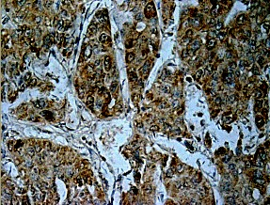

Immunohistochemical staining of formalin-fixed paraffin-embedded hepatocellular carcinoma using the anti-SLC7A5 pAb (Cat # 21118) with 1:50 dilution.

