Kim-1
Catalog Number: 21110

Gene Symbol: Kim-1
Description: Anti-Kim-1 Rabbit Polyclonal Antibody

Background: Kidney injury molecule-1 (Kim-1) is a type 1 membrane protein with extracellular immunoglobulin and mucin domains. Kim-1 mRNA and protein are expressed at very low levels in normal kidney, but expression increases dramatically after injury in proximal tubule epithelial cells in postischemic rodent kidney and in humans during ischemic acute renal failure.
Tested applications: ELISA, WB, IHC, IP

Recommended dilutions:
ELISA 1:100-1:5000
WB 1:100-1:1000
IHC 1:50-1:100
Concentration: 0.2 mg/ml
Host: Rabbit
Clonality: Polyclonal Purity: Purified from serum Format: Liquid

Storage buffer:
Preservative: no
Constituents: PBS (without Mg²⁺ and Ca²⁺), pH 7.4, 150 mM NaCl, 50% glycerol
Species Reactivity: Kim-1 antibody recognizes Kim-1 from vertebrates.
Storage Conditions: Store at -20°C. Avoid freeze / thaw cycles

Western blot:

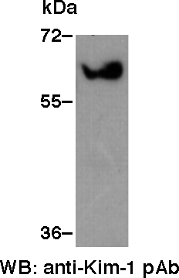

HEK 293T cell lysate was used for western blot with anti-Kim-1 polyclonal antibody (Cat # 21110).

