Actin
Catalog Number: 21011
Gene Symbol: ACTB
Description: Anti-β-actin Rabbit Polyclonal Antibody

Background: Actin is expressed in all eukaryotic cells and is the major component of the cytoskeleton. At least six types of actin are present in mammalian tissues and fall into three classes. α-actin expression is limited to various types of muscle and it regulates contactile potentials for the muscle cells, whereas β and γ actins, also known as cytoplasmic actins, are predominantly expressed in nonmuscle cells, controlling cell structure and motility.
Immunogen: Synthetic peptide from the N-terminal of β-actin
Tested applications: ELISA, WB, IHC

Recommended dilutions:
ELISA 1:1000-1:5000
WB 1:100-1:2000
IHC 1:50-1:100
Concentration: 0.2 mg/ml
Host: Rabbit
Clonality: Polyclonal Purity: Purified from serum Format: Liquid

Storage buffer:
Preservative: no
Constituents: PBS (without Mg²⁺ and Ca²⁺), pH 7.4, 150 mM NaCl, 50% glycerol
Species Reactivity: Anti-β-actin antibody recognizes β-actin of vertebrates and invertebrates
Storage Conditions: Store at -20°C. Avoid freeze / thaw cycles

Western Blot:
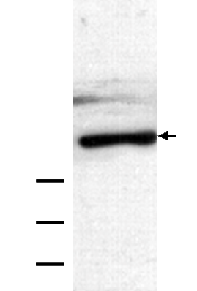



HEK-293T whole-cell lysate was used for western blot with anti-β-actin polyclonal antibody (cat # 21011).

