ALK
Catalog Number: 21280
Gene Symbol: ALK, CD246, NBLST3
Description: Anti-ALK Rabbit Polyclonal Antibody

Background: Anaplastic lymphoma kinase (ALK) also known as ALK tyrosine kinase receptor or CD246 (cluster of differentiation 246) is a neuronal orphan receptor tyrosine kinase. ALK is essentially and transiently expressed in specific regions of the central and peripheral nervous systems and plays an important role in the genesis and differentiation of the nervous system. Abnormal ALK, by fusion with other genes, gaining additional gene copies or mutations, can be oncogenic.
Immunogen: Purified ALK protein, human origin.
Tested applications: ELISA, WB, IHC

Recommended dilutions:
ELISA: 1:1000-1:5000
WB: 1:100-1:1000
IHC: 1:50-1:200
Concentration: 0.2mg/ml
Host:Rabbit Clonality: Polyclonal
Purity: Purified from serum
Format: Liquid

Storage buffer:
Preservative: no
Constituents: PBS (without Mg²⁺ and Ca²⁺), pH 7.4, 150 mM NaCl, 50% glycerol
Species Reactivity: Recognizes ALK of vertebrates.
Storage Conditions: Store at -20°C. Avoid freeze / thaw cycles

Western blot:
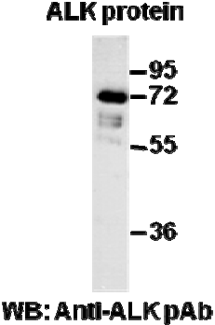
Western blot analysis of recombinant ALK protein. Purified His-tagged ALK protein was blotted with anti-ALK rabbit polyclonal antibody (Cat. #21280).

Immunohistochemistry:
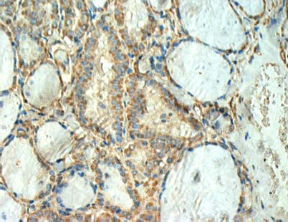
Immunohistochemical analysis of
paraffin-embedded human thyroid cancer tissue with anti-ALK polyclonal antibody (Cat. #21280). Tissue samples were fixed with formaldehyde and blocked with 1% serum for 15 min at 37 °C. Antigen retrieval was by heat mediation in citrate buffer (pH6). Samples were then incubated with primary antibody (1:50 dilution) overnight at 4°C. A HRP-conjugated Goat anti- Rabbit IgG (1:50 dilution) was used as secondary antibody.

