ATM
Catalog Number: 21276

Gene Symbol: ATM
Description: Anti-ATM Rabbit Polyclonal Antibody

Background: Ataxia telangiectasia mutated (ATM) is a serine/threonine protein kinase that is recruited and activated by DNA double-strand breaks. It phosphorylates several key proteins that initiate activation of the DNA damage checkpoint, leading to cell cycle arrest, DNA repair or apoptosis. Activity of ATM protein is under tight control, and mutation of ATM can cause disease such as Ataxia telangiectasia (AT) and cancers.
Immunogen: Purified ATM protein, human origin.
Tested applications: ELISA, WB, IHC

Recommended dilutions:
ELISA: 1:1000-1:5000
WB: 1:100-1:1000
IHC: 1:50-1:200
Concentration: 0.2mg/ml
Host: Rabbit
Clonality: Polyclonal Purity: Purified from serum Format: Liquid

Storage buffer:
Preservative: no
Constituents: PBS (without Mg²⁺ and Ca²⁺), pH 7.4, 150 mM NaCl, 50% glycerol
Species Reactivity: Recognizes ATM of vertebrates.
Storage Conditions: Store at -20°C. Avoid freeze / thaw cycles

Western blot:
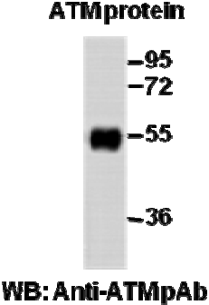
Western blot analysis of recombinant ATM protein. Purified His-tagged ATM protein was blotted with anti-ATM rabbit polyclonal antibody (Cat. #21276).

Immunohistochemistry:
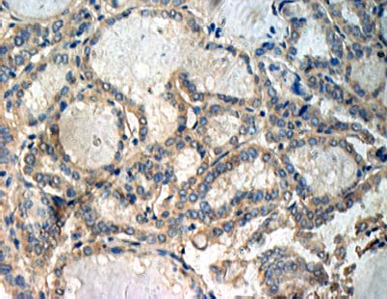
Immunohistochemical analysis of
paraffin-embedded human thyroid cancer tissue with anti-ATM polyclonal antibody (Cat. #21276). Tissue samples were fixed with formaldehyde and blocked with 1% serum for 15 min at 37 °C. Antigen retrieval was by heat mediation in citrate buffer (pH6). Samples were then incubated with primary antibody (1:50 dilution) overnight at 4°C. A HRP-conjugated Goat anti-mouse IgG (1:50 dilution) was used as secondary antibody.

