B-Raf
Catalog Number: 21271
Gene Symbol: B-RAF, B-RAF1, RAFB1
Description: Anti-B-Raf Rabbit Polyclonal Antibody

Background: B-Raf is a member of the Raf family of Ser/Thr protein kinases. It functions downstream of Ras to regulate the MAP kinase signaling pathway. Mutations in the B-RAF gene cause diseases. Inherited mutations in B-RAF cause cardiofaciocutaneous syndrome. Acquired mutations in B-RAF have been found in cancers. Immunogen: Purified B-Raf protein, human origin.
Tested applications: ELISA, WB, IHC

Recommended dilutions:
ELISA: 1:1000-1:5000
WB: 1:100-1:1000
IHC: 1:50-1:200
Concentration: 0.1mg/ml
Host: Rabbit
Clonality: Polyclonal Purity: Purified from serum Format: Liquid

Storage buffer:
Preservative: no
Constituents: PBS (without Mg²⁺ and Ca²⁺), pH 7.4, 150 mM NaCl, 50% glycerol
Species Reactivity: Recognizes B-Raf of vertebrates.
Storage Conditions: Store at -20°C. Avoid freeze / thaw cycles

Immunohistochemistry:
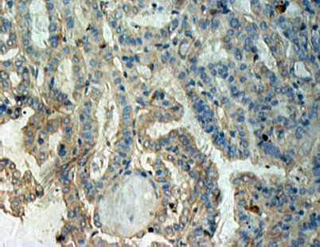
Immunohistochemical analysis of
paraffin-embedded human thyroid cancer tissue with anti- B-Raf polyclonal antibody (Cat. #21271). Tissue samples were fixed with formaldehyde and blocked with 1% serum for 15 min at 37 °C. Antigen retrieval was by heat mediation in citrate buffer (pH6). Samples were then incubated with primary antibody (1:50 dilution) overnight at 4°C. A HRP-conjugated Goat anti-mouse IgG (1:50 dilution) was used as secondary antibody.

