TP53
Catalog Number: 21270
Gene Symbol: TP53
Description: Anti-TP53 Rabbit Polyclonal Antibody

Background: TP53 belongs to the p53 proteins family. It is ubiquitously expressed, acts as a tumor suppressor in many tumor types and induces growth arrest or apoptosis depending on the physiological circumstances and cell type.
Defects in TP53 are a cause of esophageal cancer (ESCR), lung cancer (LNCR), adrenocortical carcinoma (ADCC), choroid plexus papilloma (CPLPA) and so on.
Immunogen: A synthetic peptide from the internal region of TP53 protein, human origin. Tested applications: ELISA, WB, IHC Recommended dilutions:
ELISA 1:500-1:5000
WB 1:500-1:2000
IHC 1:50-200
Concentration: 0.2 mg/ml
Host: Rabbit
Clonality: Polyclonal Purity: Purified from serum Format: Liquid

Storage buffer:
Preservative: no
Constituents: PBS (without Mg²⁺ and Ca²⁺), pH 7.4, 150 mM NaCl, 50% glycerol
Species Reactivity: Anti-TP53 rabbit polyclonal antibody recognizes TP53 from vertebrates.
Storage Conditions: Store at -20°C. Avoid freeze / thaw cycles

Western blot:
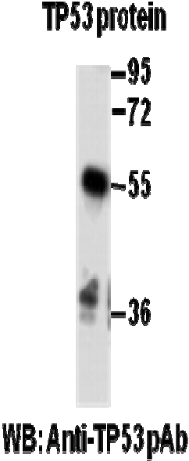

Western blot analysis of recombinant TP53 protein. Purified full length His-tagged TP53 protein was blotted with anti-TP53 rabbit polyclonal antibody (Cat. #21270).

