Septin 9
Catalog Number: 21126
Gene Symbol: SEPT9
Description: Anti-Septin 9 Rabbit Polyclonal Antibody

Background: Septin-9 belongs to the septin family. It is essential for pseudopod protrusion, tumor cell migration and invasion.
Immunogen: A synthetic peptide from the internal region of Septin-9 isoform of human origin.
Tested applications: ELISA, WB, IHC, IP

Recommended dilutions:
ELISA: 1:1000-1:5000
WB: 1:100-1:1000
IHC: 1:50-1:100
Concentration: 0.2 mg/ml
Host: Rabbit
Clonality: Polyclonal Purity: Purified from serum Format: Liquid

Storage buffer:
Preservative: no
Constituents: PBS (without Mg²⁺ and Ca²⁺), pH 7.4, 150 mM NaCl, 50% glycerol
Species Reactivity: Anti-Septin-9 antibody recognizes Septin-9 of vertebrates.
Storage Conditions: Store at -20°C. Avoid freeze
/ thaw cycles

Western blot:




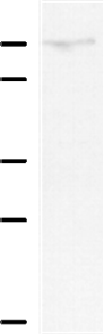
Whole-cell lysate of HEK293T cells was used for western blot with the polyclonal anti-Septin-9 antibody (Cat # 21126).

