SUMO-2/3

Catalog Number: 21237 Gene Symbol: SUMO2/3
Description: Anti-SUMO-2/3 Rabbit polyclonal Antibody

Background: Small Ubiquitin-like Modifier or SUMO proteins are a family of small proteins that are covalently attached to and detached from other proteins in cells to modify their function. SUMOylation is a post-translational modification involved in various cellular processes, such as nuclear-cytosolic transport, transcriptional regulation, apoptosis, protein stability, response to stress, and progression through the cell cycle. There are 3 confirmed SUMO isoforms in humans: SUMO-1, SUMO-2 and SUMO-3. SUMO-2 and -3 show a high degree of similarity to each other and are distinct from SUMO-1.
Immunogen: A synthetic peptide corresponding
to residues near the C-terminal of human SUMO-2/3.
Tested applications: ELISA, WB, IHC, IP

Recommended dilutions:
ELISA: 1:1000-1:5000
WB: 1:100-1:1000
IHC: 1:50-1:100
Concentration: 1 mg/ml
Host: Rabbit
Clonality: polyclonal Purity: Purified from serum Format: Liquid Preservative: no
Constituents: PBS (without Mg²⁺ and Ca²⁺), pH 7.4, 150 mM NaCl, 50% glycerol
Species Reactivity: Detects SUMO-2/3 but not SUMO-1 from vertebrates.
Storage Conditions: Store at -20°C. Avoid freeze / thaw cycles

Western blot:

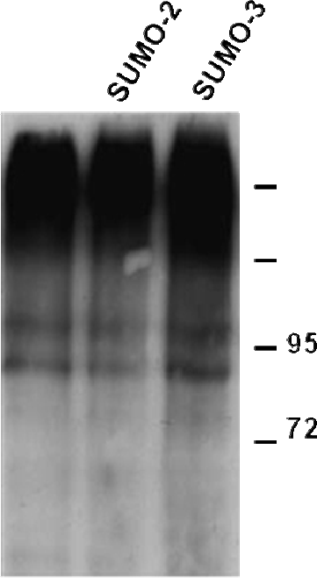



Western blot analysis of over-expressed SUMO-2 and SUMO-3 proteins. HEK293 cells were transfected with SUMO-2 (lane 2) and SUMO-3 (lane 3) cDNAs and control empty vector (lane 1). Cell lysates were blotted with anti-SUMO-2/3 rabbit polyclonal antibody (Cat. # 21237).

