Orai1
Catalog Number: 21001
Gene Symbol: Orai1
Description: Orai1 Rabbit Polyclonal Antibody (Orai1-L1)

Background: Store-operated calcium channels (SOCs) play essential functions in various physiological processes. Orai1 (also named CRACM1) is a critical molecular component of SOCs. Orai1 protein is a ~35 kDa plasma membrane protein with 4 transmembrane domains. Human patients with
a severe combinaed immunodeficiency (SCID) syndrome possess point mutations in Orai1 gene.
Immunogen: A peptide from the extracellular loop 1 region of human Orai1 Tested applications: ELISA, WB, IHC Recommended dilutions:
ELISA 1:1000-1:5000,
WB 1:1000-1:2000,
IHC 1:100-1:200
Host: Rabbit Clonality: Polyclonal Isotype: IgG
Purity : Immunogen affinity purified
Format: Liquid

Storage buffer:
Preservative: 0.01% sodium azide Constituents: 50mM NaHCO₃-Glycine, 0.15M NaCl, pH7.4
Species Reactivity: Orai1-L1 antibody recognizes Orai1 from human and mouse. It may also recognize Orai2 and Orai3.
Storage Conditions: Store at -20°C. Avoid freeze / thaw cycles

Western blot

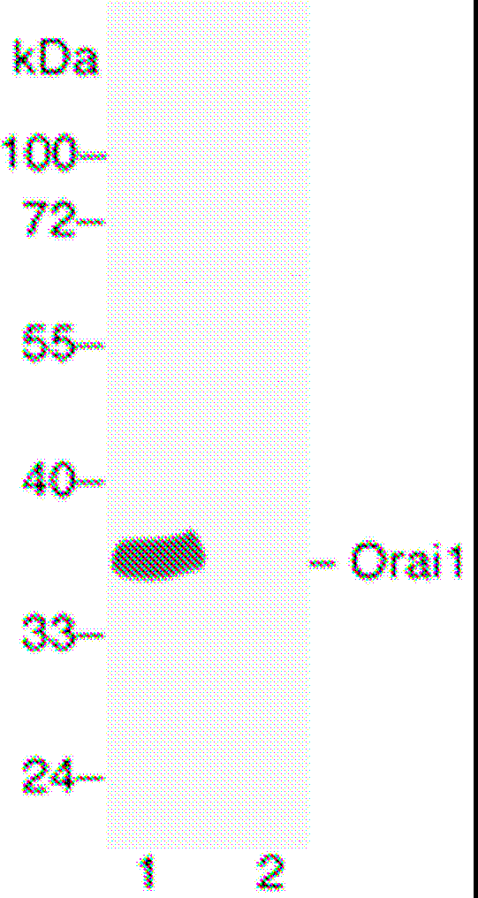
Western blot analysis of Orai1 protein. Human Orai1 plasmid DNA was transiently transfected into
HEK-293 cells. Whole-cell lysate was used for western blot in the absence (lane 1) or presence (lane
2) of antigen peptide.

Immunohistochemistry

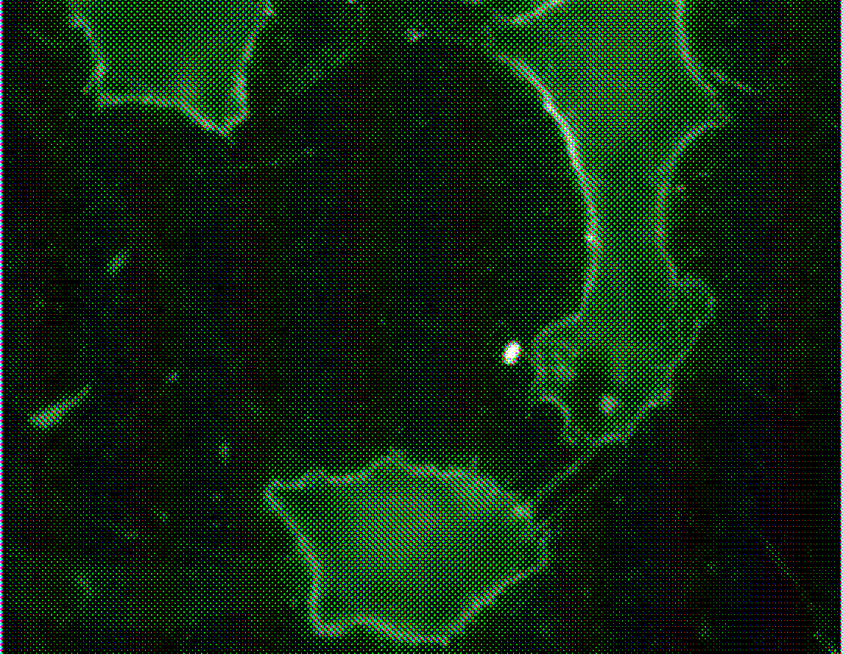

Immunohistochemistry of endogenous Orai1 in NIH3T3 cells showing the plasma membrane staining.

