Orai1
Catalog Number: 21002
Gene Symbol: Orai1
Description: Orai1 Rabbit Polyclonal Antibody (Orai1-L2)

Background: Store-operated calcium channels (SOCs) play essential functions in various physiological processes. Orai1 (also named CRACM1) is a critical molecular component of SOCs. Orai1 protein is a ~35 kDa plasma membrane protein with 4 transmembrane domains. Human patients with
a severe combinaed immunodeficiency (SCID) syndrome possess point mutations in Orai1 gene.
Immunogen: A peptide from the extracellular loop 2 region of human Orai1 Tested applications: ELISA, WB Recommended dilutions:
ELISA 1:1000-1:5000,
WB 1:1000-1:2000,
IHC 1:100-1:200
Host: Rabbit Clonality: Polyclonal Isotype: IgG
Purity : Immunogen affinity purified
Format: Liquid

Storage buffer:
Preservative: 0.01% sodium azide Constituents: 50mM NaHCO₃-Glycine, 0.15M
NaCl, pH7.4
Species Reactivity: Orai1-L2 antibody recognizes Orai1 from human.
Storage Conditions: Store at -20°C. Avoid freeze / thaw cycles

Western blot

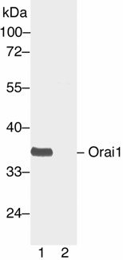
Western blot analysis of Orai1 protein. Human Orai1 plasmid DNA was transiently transfected into
HEK-293 cells. Whole-cell lysate was used for western blot in the absence (A) or presence (B) of antigen peptide.

