β-Tubulin
Catalog Number: 21089

Gene Symbol: TUBB
Description: Anti-β-Tubulin Rabbit Polyclonal Antibody

Background: There are ﬁve members of the tubulin family (α, β, γ, δ, and ε). The most common members are α and β tubulins which form heterodimers as the basic structural unit of microtubules.
Immunogen: A synthetic peptide from the internal region of human β -tubulin protein
Tested applications: ELISA, WB, IHC, IP

Recommended dilutions:
ELISA 1:100-1:5000
WB 1:100-1:1000
IHC 1:50-1:100
Concentration: 0.2 mg/ml
Host: Rabbit
Clonality: Polyclonal Purity: Purified from serum Format: Liquid

Storage buffer:
Preservative: no
Constituents: PBS (without Mg²⁺ and Ca²⁺), pH 7.4, 150 mM NaCl, 50% glycerol
Species Reactivity: β-Tubulin antibody recognizes β-tubulin proteins from vertebrates. Storage Conditions: Store at -20°C. Avoid freeze / thaw cycles

Western blot:

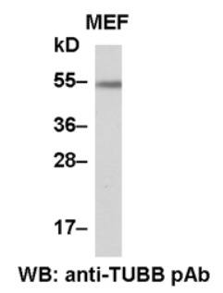

MEF whole-cell lysate was used for Western blot with anti-β-tubulin polyclonal antibody (Cat # 21089).

Immunohistochemistry:

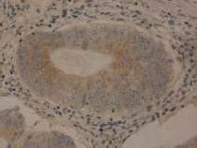

Immunohistochemical staining of formalin-fixed paraffin-embedded colon carcinoma using the affinitty purified anti β-tubulin polyclonal antibody (Cat# 21089) with a 1:50 dilution.

