EYA2
Catalog Number: 21128
Gene Symbol: EYA2
Description: Anti- EYA2 Rabbit Polyclonal Antibody

Background: EYA2 (eyes absent homolog 2) functions as a tyrosine phosphatase that specifically dephosphorylates Tyr-142 of histone H2AX. EYA2 promotes efficient DNA repair and coactivates SIX1. Together with SIX1 and DACH2, EYA2 seems to be involved in myogenesis.
Immunogen: A synthetic peptide from the internal region of human EYA2.
Tested applications: ELISA, WB, IHC, IP

Recommended dilutions:
ELISA: 1:1000-1:5000
WB: 1:100-1:1000
IHC: 1:100-1:1000
Concentration: 0.1 mg/ml
Host: Rabbit
Clonality: Polyclonal Purity: Purified from serum Format: Liquid

Storage buffer:
Preservative: no
Constituents: PBS (without Mg²⁺ and Ca²⁺), pH 7.4, 150 mM NaCl, 50% glycerol
Species Reactivity: Anti-EYA2 antibody recognizes EYA2 of vertebrates.
Storage Conditions: Store at -20°C. Avoid freeze / thaw cycles

Western blot:

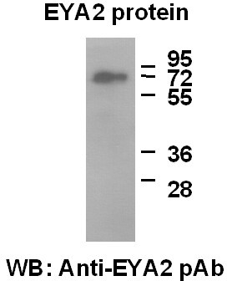
Western blot analysis of recombinant full length EYA2 protein. Purified His-tagged EYA2 protein (Cat. #10195) was blotted with anti-EYA2 polyclonal antibody (Cat # 21128).

