Albumin
Catalog Number: 21112

Gene Symbol: Albumin
Description: Anti-Albumin Rabbit Polyclonal Antibody

Background: Serum albumin is the most abundant blood plasma protein in mammals. Albumin is essential for maintaining the osmotic pressure needed for proper distribution of body fluids between intravascular compartments and body tissues. It also acts as a plasma carrier by non-specifically binding several hydrophobic steroid hormones and as a transport protein for hemin and fatty acids. Too much serum albumin in the body can be harmful.
Immunogen: A synthetic peptide from the N-terminal region of human Albumin protein Tested applications: ELISA, WB, IHC, IP Recommended dilutions:
ELISA 1:100-1:5000
WB 1:100-1:1000
IHC 1:100-1:1000
Concentration: 0.2 mg/ml
Host: Rabbit
Clonality: Polyclonal Purity: Purified from serum Format: Liquid

Storage buffer:
Preservative: no
Constituents: PBS (without Mg²⁺ and Ca²⁺), pH 7.4, 150 mM NaCl, 50% glycerol
Species Reactivity: Albumin antibody recognizes Albumin proteins from mammals.
Storage Conditions: Store at -20°C. Avoid freeze
/ thaw cycles

Western blot:
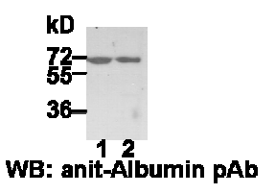

HEK-293T (lane 1) and MEF (lane 2) whole-cell lysates were used for Western blot with anti-Albumin polyclonal antibody (cat # 21112).

