MUC1
Catalog Number: 21123
Gene Symbol: MUC1
Description: Anti- MUC1 Rabbit Polyclonal Antibody

Background: Mucin-1 proteins line the apical surface of highly polarized epithelial cells in the lungs, stomach, intestines, and eyes. Mucins protect the body from infection by pathogen binding to oligosaccharides in the extracellular domain. Overexpression of MUC1 is often associated with colon, breast, ovarian, lung, and pancreatic cancers.
Immunogen: A synthetic peptide from the internal region of MUC1 of human origin. Tested applications: ELISA, WB, IHC, IP Recommended dilutions:
ELISA: 1:1000-1:5000
WB: 1:100-1:1000
IHC: 1:50-1:100
Concentration: 1 mg/ml
Host: Rabbit
Clonality: Polyclonal Purity: Purified from serum Format: Liquid

Storage buffer:
Preservative: no
Constituents: PBS (without Mg²⁺ and Ca²⁺), pH 7.4, 150 mM NaCl, 50% glycerol
Species Reactivity: Anti-MUC1 antibody recognizes MUC1 of vertebrates.
Storage Conditions: Store at -20°C. Avoid freeze / thaw cycles

Western blot:

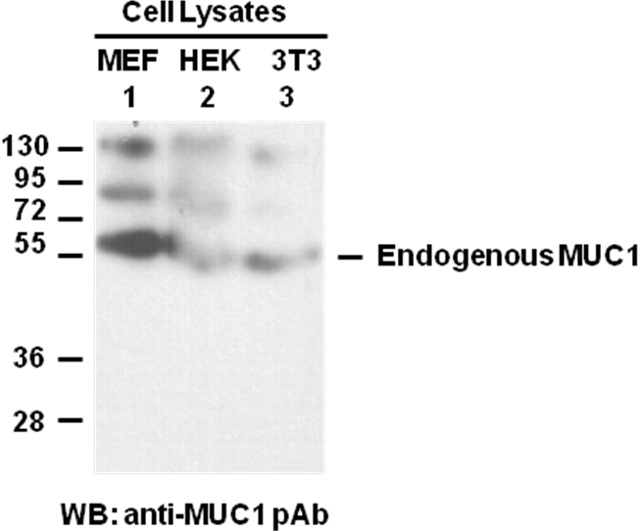

Whole-cell lysates of MEF (lane 1), HEK293 (lane 2) and NIH3T3 (lane 3) cells were used for western blot with the polyclonal anti-MUC1 antibody (Cat # 21123).

