Transferrin
Catalog Number: 26050

Gene Symbol: TF
Description: Anti-Transferrin Mouse Monoclonal Antibody

Background: Transferrins are iron-binding blood plasma glycoproteins that control the level of free iron in biological fluids. Serum transferrin level could be monitored for iron deficiency, hemochromatosis, and other iron overload disorders.
Immunogen: A synthetic peptide near the N-terminus of human transferrin protein. Tested applications: ELISA, WB, IHC, IP

Recommended dilutions:
ELISA 1:1000-1:5000
WB 1:100-1:2000
IHC 1:50-1:100
Concentration: 1 mg/ml
Host: Mouse
Clonality: Monoclonal Purity: Purified from ascites Format: Liquid

Storage buffer:
Preservative: no
Constituents: PBS (without Mg²⁺ and Ca²⁺), pH 7.4, 150 mM NaCl, 50% glycerol
Species Reactivity: Anti-transferrin antibody recognizes transferrin of vertebrates
Storage Conditions: Store at -20°C. Avoid freeze / thaw cycles

Western Blot:
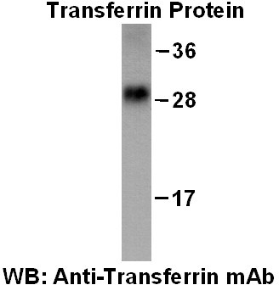

Purified His-tagged transferrin protein (Cat. #10192) was used for Western blot with anti-transferrin monoclonal antibody (Cat. # 26050).

