EYA2
Catalog Number: 26052
Gene Symbol: EYA2
Description: Anti- EYA2 Mouse Monoclonal Antibody

Background: EYA2 may be involved in development of the eye. It promotes efficient DNA repair by dephosphorylating H2AX, promoting the recruitment of DNA repair complexes containing MDC1. Its function as histone phosphatase probably explains its role in transcription regulation during organogenesis.
EYA2 coactivates SIX1 and seems to coactivate SIX2, SIX4 and SIX5. It seems to be involved in myogenesis together with SIX1 and DACH2 .
Immunogen: A synthetic peptide near the N-terminus of EYA2, human origin.
Tested applications: ELISA, WB, IHC

Recommended dilutions:
ELISA: 1:1000-1:5000
WB: 1:100-1:1000
IHC: 1:50-1:100
Concentration: 1 mg/ml
Host: Mouse
Clonality: Monoclonal Purity: Purified from ascites Format: Liquid

Storage buffer:
Preservative: no
Constituents: PBS (without Mg²⁺ and Ca²⁺), pH 7.4, 150 mM NaCl, 50% glycerol
Species Reactivity: Anti-EYA2 antibody recognizes EYA2 of vertebrates.
Storage Conditions: Store at -20°C. Avoid freeze / thaw cycles

Western blot:

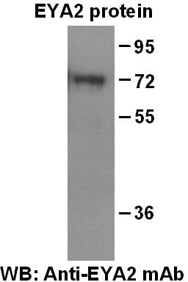
Western blot analysis of recombinant full length EYA2 protein. Purified His-tagged EYA2 protein(Cat. #10195) was blotted with anti-EYA2 monoclonal antibody (Cat # 26052).

Immunohistochemistry:
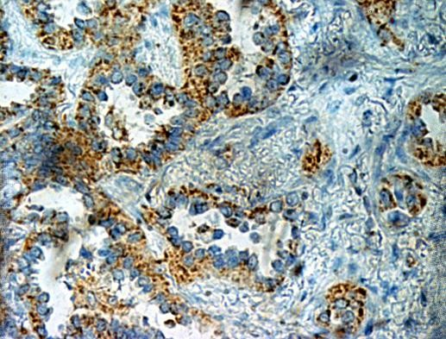
Immunohistochemical analysis of
paraffin-embedded human adenocarcinoma tissue with anti-EYA2 monoclonal antibody (Cat. # 26052). Tissue section was fixed with formaldehyde and blocked with 1% serum for 15 min at 37 °C. Antigen retrieval was by heat mediation in citrate buffer (pH6). Samples were

then incubated with primary antibody (1:50) overnight at 4°C . A HRP-conjugated Goat anti-mouse IgG (dilution 1:50) was used as secondary antibody.

