Albumin mAb
Catalog Number: 26090

Gene Symbol:ALB
Description: Anti-Albumin Mouse Monoclonal Antibody

Background: Albumin belongs to the ALB/AFP/VDB family. It is a soluble, monomeric protein which comprises about one-half of the blood serum protein. Albumin functions primarily as a carrier protein for
steroids, fatty acids, and thyroid hormones, and also plays a role in stabilizing extracellular fluid volume. Defects in Albumin will cause familial dysalbuminemic hyperthyroxinemia (FDH).
Immunogen:Albumin protein, human origin. Tested applications: ELISA, WB, IHC Recommended dilutions:
ELISA: 1:1000-1:5000
WB: 1:1000-1:5000
IHC: 1:50-1:100
Concentration: 1 mg/ml
Host: Mouse
Clonality: Monoclonal Purity: Purified from ascites Format: Liquid

Storage buffer:
Preservative: no
Constituents: PBS (without Mg²⁺ and Ca²⁺), pH 7.4, 150 mM NaCl, 50% glycerol
Species Reactivity: Anti-Albumin antibody
recognizes Albumin from vertebrates. Storage Conditions: Store at -20°C. Avoid freeze / thaw cycles.

Western blot:

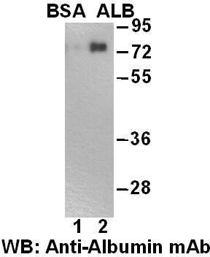
Western blot analysis of HSA(Albumin) and BSA proteins. Purified Albumin protein(lane 1)and BSA protein(lane 2)were blotted with
anti-Albumin monoclonal antibody(Cat. # 26090)

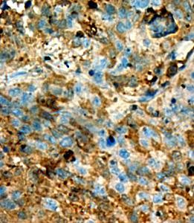
Immunohistochemistry:
Immunohistochemical analysis of
paraffin-embedded liver cancer tissue with
anti-Albumin monoclonal antibody (Cat.
#26090). Tissue samples were fixed with formaldehyde and blocked with 1% serum for 15
min at 37 °C. Antigen retrieval was by heat mediation in citrate buffer (pH6). Samples were then incubated with primary antibody (1:50) overnight at 4°C . A HRP-conjugated Goat
anti-mouse IgG (dilution 1:50) was used as secondary antibody.

For research use only. Not for diagnostic or therapeutic applications.

24 Whitewoods Lane, Malvern, PA 19355 Tel: (610) 945-2007 FAX: (610) 945-2008
E-mail: sale@neweastbio.com Web: www.neweastbio.com

