Apolipoprotein A1
Catalog Number: 26023

Gene Symbol: APOA1
Description: Anti-Apolipoprotein A1 Mouse Monoclonal Antibody

Background: Apolipoprotein A1 is the major protein component of high-density lipoprotein (HDL) (“good cholesterol”) in plasma.
Apolipoprotein A1 helps to clear cholesterol from arteries.
Immunogen: A synthetic peptide from the C-terminal region of Apolipoprotein A1 Tested applications: ELISA, WB, IHC Recommended dilutions:
ELISA 1:100-1:5000
WB 1:100-1:2000
IHC 1:100-1:1000
Concentration: 1 mg/ml
Host: mouse Clonality: Monoclonal Isotype: IgG
Purity: Purified from ascites
Format: Liquid

Storage buffer:
Preservative: no
Constituents: PBS (without Mg²⁺ and Ca²⁺), pH 7.4, 150 mM NaCl, 50% glycerol
Species Reactivity: Apolipoprotein A1 antibody recognizes Apolipoprotein A1 of primates.
Storage Conditions: Store at -20°C. Avoid freeze / thaw cycles

Western blot:
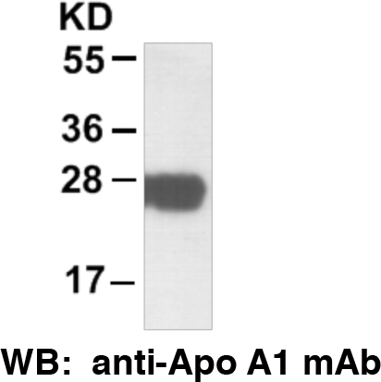

Western blot analysis of Apolipoprotein A1 protein.

