IDH1
Catalog Number: 26136
Gene Symbol: IDH1
Description: Anti-IDH1 Mouse Monoclonal Antibody

Background: Isocitrate dehydrogenase (IDH) catalyzes the oxidative decarboxylation of isocitrate to 2-oxoglutarate. Mutations of Arg-132 in IDH to Cys, His, Leu or Ser abolish magnesium binding and the conversion of isocitrate to alpha-ketoglutarate. Instead, alpha-ketoglutarate is converted to R-2-hydroxyglutarate. Elevated levels of R-2-hydroxyglutarate are correlated with an elevated risk of malignant brain tumors.
Immunogen: Recombinant proteins of human IDH1 (amino acids 1-240).
Tested applications: ELISA, WB, IHC, IP

Recommended dilutions:
ELISA: 1:1000-1:5000
WB: 1:100-1:1000
IHC: 1:50-1:100
Concentration: 1 mg/ml
Host: Mouse
Clonality: Monoclonal Purity: Purified from ascites Format: Liquid Preservative: no
Constituents: PBS (without Mg²⁺ and Ca²⁺), pH 7.4, 150 mM NaCl, 50% glycerol
Species Reactivity: Anti-IDH1 antibody recognizes IDH1 of vertebrates.
Storage Conditions: Store at -20°C. Avoid freeze / thaw cycles.

Western blot:

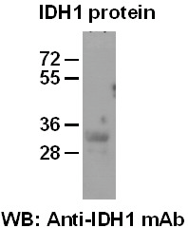
Western blot analysis of recombinant IDH1 protein. Purified His-tagged IDH1 protein (amino acids 1-240) (Cat.#10198) was blotted with anti-IDH1 mouse antibody (Cat.# 26136).

