Clusterin
Catalog Number: 26088

Gene Symbol: CLU
Description: Anti-Clusterin Mouse Monoclonal Antibody

Background: Clusterin (apolipoprotein J) belongs to the clusterin family, is a 75 - 80 kDa disulfide-linked heterodimeric protein associated with the clearance of cellular debris and apoptosis. It is a secreted chaperone that can under some stress conditions also be found in the cell cytosol. Clusterin has been suggested to be involved in several basic biological events such as cell death, tumor progression, and neurodegenerative disorders.
Immunogen: Purified clusterin protein, human origin.
Tested applications: ELISA, WB, IHC

Recommended dilutions:
ELISA: 1:1000-1:5000
WB: 1:500-1:2000
IHC: 1:50-1:100
Concentration: 1 mg/ml
Host: Mouse
Clonality: Monoclonal Purity: Purified from ascites. Format: Liquid

Storage buffer:
Preservative: no
Constituents: PBS (without Mg²⁺ and Ca²⁺), pH 7.4, 150 mM NaCl, 50% glycerol.
Species Reactivity: Anti-Clusterin antibody recognizes Clusterin of vertebrates.
Storage Conditions: Store at -20°C. Avoid freeze / thaw cycles.

Western blot:
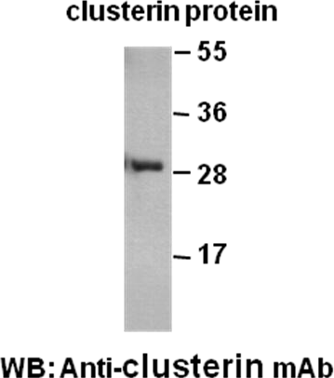

Western blot analysis of recombinant Clusterin protein. Purified His-tagged Clusterin protein (33-225) (Cat. #10160) was blotted with
anti-Clusterin mouse monoclonal antibody (Cat. #26088).

