EGFR (S768I)
Catalog Number: 26483
Gene Symbol: EGFR/HER1/ERBB1
Description: Anti-EGFR (S768I) Mouse Monoclonal Antibody

Background: EGFR is a receptor tyrosine kinase binding ligands of the EGF family and activating several signaling cascades to convert extracellular cues into appropriate cellular responses. It activates at least 4 major downstream signaling cascades including the RAS-RAF-MEK-ERK, PI3 kinase-AKT,
PLCgamma-PKC and STATs modules. Defects in EGFR are associated with lung cancer (LNCR).
Immunogen: A synthetic peptide from the internal region of EGFR which includes the mutation of S768I, human origin.
Tested applications: ELISA, WB, IF, IHC

Recommended dilutions:
ELISA: 1:1000-1:5000
WB: 1:1000-1:5000
IHC: 1:50-1:200
Concentration: 1 mg/ml
Host: Mouse
Clonality: Monoclonal Purity: Purified from ascites Format: Liquid

Storage buffer:
Preservative: no
Constituents: PBS (without Mg2+ and Ca2+), pH 7.4, 150 mM NaCl, 50% glycerol
Species Reactivity: recognizes EGFR (S768I), but not wild type EGFR from vertebrates.
Storage Conditions: Store at -20°C. Avoid freeze / thaw cycles.

Western blot:

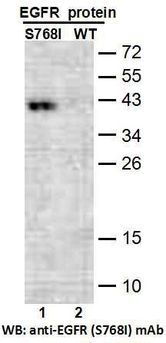
Western blot analysis of recombinant EGFR (S768I) and wildtype proteins. Purified
His-tagged EGFR (S768I) protein (lane 1) and corresponding wild type protein (amino acids 702-987, lane 2) were blotted with anti-EGFR (S768I) mouse monoclonal antibody (Cat. #26483).

Immunofluorescence:
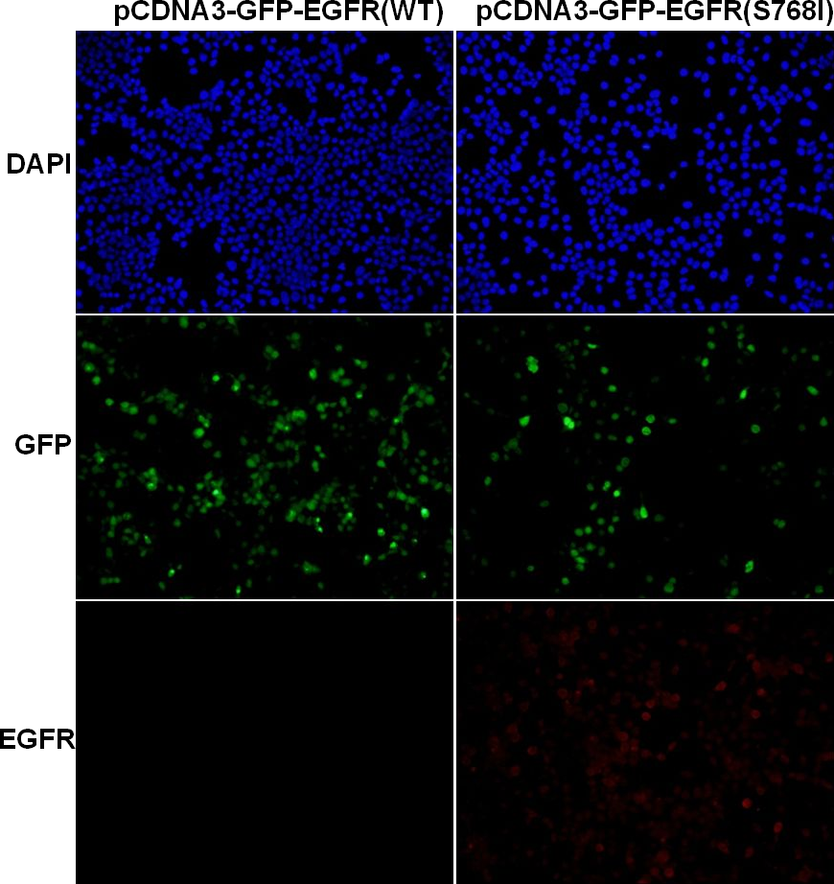
Immunofluorescence of cells expressing EGFR proteins with anti-EGFR (S768I) antibody.
HEK293T cells were transfected with
pCDNA3-GFP-EGFR (WT) plasmid (left column) or pCDNA3-GFP-EGFR (S768I) plasmid (right column), then fixed and stained with anti- EGFR (S768I) monoclonal antibody (Cat. #26483).

