cGMP
Catalog Number: 26001-1
Description: Anti-cGMP Mouse Monoclonal Antibody

Background: cGMP is a ubiquitous second messenger mediating cellular responses to various exogenous and endogenous signaling molecules. cGMP regulates physiological processes by activating protein kinases, gating specific ion channels, and modulating cellular cyclic nucleotide concentrations through phosphodiesterases. The conversion of GTP to cGMP is catalyzed by guanylyl cyclases (GCs). There are two types of GCs in mammals: the soluble and the membrane-bound GCs. The soluble GCs are generally activated when nitric oxide binds to the attached prosthetic heme group. Seven membrane-bound GCs (also named transmembrane or particulated GCs) have been identified in the human genome. GC-A and GC-B are natriuretic peptide receptors. GC-C can be activated by bacterial heat-stable enterotoxins, guanylin and uroguanylin. The activity of transmembrane GCs can also be modulated by other receptor signals through intracellular signaling pathways.
Immunogen: cGMP
Tested applications: ELISA, WB, IHC

Recommended dilutions:
ELISA 1:1000-1:5000,
WB 1:1000-1:2000,
Host: mouse Clonality: Monoclonal Isotype: IgG
Purity: Purified from ascites
Format: Liquid

Storage buffer:
Preservative: no
Constituents: PBS (without Mg²⁺ and Ca²⁺), pH 7.4,
150 mM NaCl, 50% glycerol
Storage Conditions: Store at -20°C. Avoid freeze / thaw cycles

Typical Standard Curves
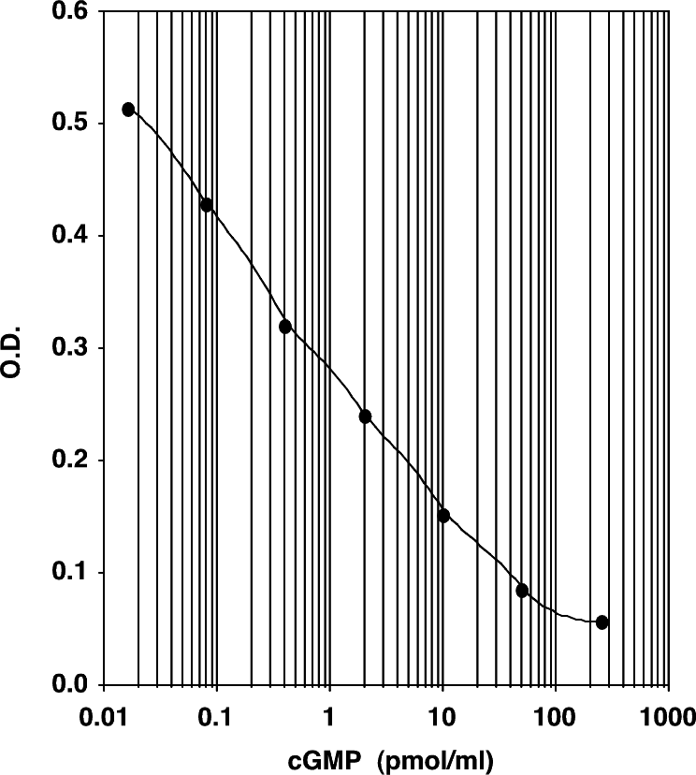

Sensitivity

Acetylated Version
Mean OD for Bo = 0.536 ± 0.010
Mean OD for Standard #6 = 0.403 ±0.009 Delta Optical Density (0-0.08 pmol/mL) = 0.133
2 SD's of the Zero Standard = 0.020
Sensitivity =0.020 0.08 pmol/mL = 12 fmol/mL
×
0.133

