Active RhoA
Catalog Number: 26904

Gene Symbol: RHOA
Description: Anti-Active RhoA Mouse Monoclonal Antibody

Background: Small GTPases are a super-family of cellular signaling regulators. RhoA belongs to the Rho sub-family of GTPases. Rho proteins play critical roles in many actin cytoskeleton- dependent processes including platelet aggregation, cell motility, contraction, and cytokinesis. It regulates the formation of stress fibers and focal adhesions in fibroblasts and Ca²⁺ sensitivity of smooth muscle contraction.
Immunogen: Recombinant full length protein of active RhoA
Tested applications: IP, IHC

Recommended dilutions:
1 μg for 1~2 mg total cellular proteins
Concentration: 1 mg/ml
Host: mouse
Clonality: Monoclonal Isotype: IgG2b, IgM Purity: Purified from ascites
Format: Liquid

Storage buffer:
Preservative: no
Constituents: PBS (without Mg²⁺ and Ca²⁺), pH 7.4, 150 mM NaCl, 50% glycerol
Species Reactivity: Anti-active RhoA antibody recognizes active RhoA from vertebrates.
Storage Conditions: Store at -20°C. Avoid freeze / thaw cycles

Immunoprecipitation and Western blot:
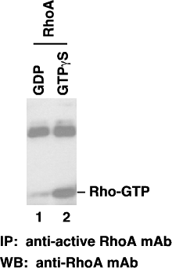

IP/WB analysis of active RhoA protein. Purified recombinant RhoA proteins were loaded with GDP (lane 1) or GTPgS (lane 2). These proteins were immunoprecipitated with anti-active RhoA mouse monoclonal antibody (Cat. # 26904).
After SDS/PAGE, the membrane filter was probed with anti-RhoA mouse monoclonal antibody (Cat. # 26007).

