Active Arl3
Catalog Number: 26925

Gene Symbol: ARL3
Description: Anti-active Arl3 Mouse Monoclonal Antibody

Background: Arl3 (Arf-like 3) is an Arf family protein. Arl3 binds microtubules to alter specific aspects of cytokinesis. It has been proposed that retinitis pigmentosa 2 functions in concert with Arl3 to link the cell membrane and the cytoskeleton in photoreceptors as part of the cell signaling or vesicular transport machinery.
Immunogen: Recombinant Arl3 protein (active form)
Tested applications: IP, IHC, IF

Recommended dilutions:
1 μg for 1~2 mg total cellular proteins for IP 1:50~100 dilutions for IHC and IF Concentration: 1 mg/ml
Host: Mouse
Clonality: Monoclonal Purity: Purified from ascites Format: Liquid

Storage buffer:
Preservative: no
Constituents: PBS (without Mg²⁺ and Ca²⁺), pH 7.4, 150 mM NaCl, 50% glycerol.
Species Reactivity: Arl3 antibody recognizes active Arl3-GTP from vertebrates.
Storage Conditions: Store at -20°C. Avoid freeze / thaw cycles.

Immunoprecipitation and Western blot:

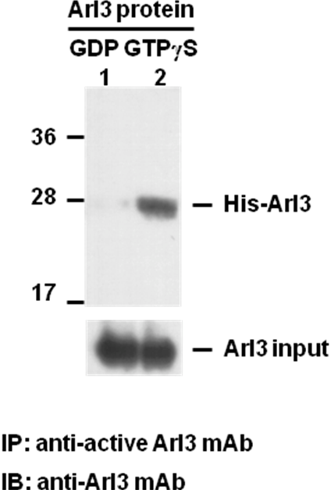

Arl3 Activation Assay. Purified His-tagged Arl3 proteins (Cat. #10152) were immunoprecipitated with the anti-active Arl3 monoclonal antibody (Cat. #26925) after treated with GDP (lane 1) or GTPγS (lane 2), and was blotted with anti-Arl3 monoclonal antibody (Cat. #21070). Input controls are shown in the bottom panel.

