Active Gα₁₃
Catalog Number: 26902
Gene Symbol: Gna13
Description: Anti-Active Gα₁₃-GTP Mouse Monoclonal Antibody

Background: Heterotrimeric G proteins are essential cellular signal transducers. Gα₁₃ is one of the G proteins that could mediate cell migration and angiogenesis. Other biochemical and physiological functions of Gα₁₃ are being explored.
Immunogen: Recombinant full length active Gα₁₃ protein
Tested applications: IP, IHC

Recommended dilutions:
1 μg for 1~2 mg total cellular proteins
Concentration: 1 mg/ml
Host: mouse Clonality: Monoclonal Isotype: IgG1, IgG2b
Purity : Purified from ascites
Format: Liquid

Storage buffer:
Preservative: no
Constituents: PBS (without Mg²⁺ and Ca²⁺), pH 7.4, 150 mM NaCl, 50% glycerol
Species Reactivity: Anti-active Gα₁₃
monoclonal antibody recognizes active Gα₁₃ of vertebrates.
Storage Conditions: Store at -20°C. Avoid freeze / thaw cycles

Immunoprecipitation/Western blot:

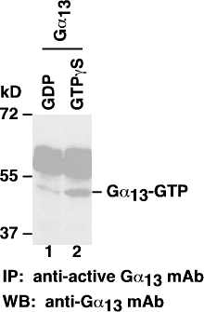

IP/WB analysis of active Gα₁₃ proteins. Purified Gα₁₃ proteins were treated with GDP (lane 1) or GTPγS (lane 2). After immunoprecipitation with anti-active Gα₁₃-GTP mouse monoclonal antibody (Cat. # 26902), these proteins were separated by SDS/PAGE and western blotted with anti- Gα₁₃ mouse monoclonal antibody (Cat. # 26004).

