Active Gα_{i}
Catalog Number: 26901
Gene Symbol: Gnai
Description: Anti-Active Gα_{i} Mouse Monoclonal Antibody

Background: Heterotrimeric G proteins are critical cellular signal transducers. Gα_{i} represents one
sub-family of G proteins that could mediate the inhibition of adenylyl cyclases. Other biochemical and physiological functions of Gα_{i} proteins are being explored.
Immunogen: Recombinant full length protein of active Gα_{i1}
Tested applications: IP, IHC

Recommended dilutions:

1 μg for 1~2 mg total cellular proteins
Concentration: 1 mg/ml
Host: mouse Clonality: Monoclonal Isotype: IgG1
Purity: Purified from ascites
Format: Liquid

Storage buffer:

Preservative: no
Constituents: PBS (without Mg²⁺ and Ca²⁺), pH 7.4, 150 mM NaCl, 50% glycerol
Species Reactivity: Anti-active Gα_{i} antibody

recognizes active Gα_{i1}, Gα_{i2}, and Gα_{i3} of vertebrates.
Storage Conditions: Store at -20°C. Avoid freeze / thaw cycles

Immunoprecipitation/Western blot

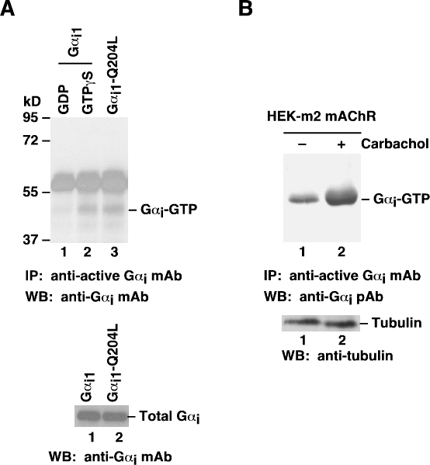
Gα_{i} activation assay. A. CHO cells were transfected with wild-type Gα_{i1} (lanes 1 and 2) or constitutively active Gα_{i1}-Q204L (lane 3). Cell lysates were treated with GDP (lane 1) or GTPγS (lane 3). Lysates were then incubated with an anti-active Gα_{i} monoclonal antibody (Cat. No.
26901) (top panel). The precipitated active Gα_{i} was immunoblotted with an anti- Gα_{i} monoclonal antibody (Cat. No. 26003). The bottom panel shows the Western blot with anti- Gα_{i} monoclonal antibody (Cat.No. 26003) of the cell lysates. B. HEK293 cells stably expressing human m2 mAChR were treated with (lane 2) or without (lane 1) carbachol. Cell lysates were then incubated with an
anti-active Gα_{i} monoclonal antibody (Cat. No. 26901) (top panel). The precipitated active Gα_{i} was immunoblotted with an anti- Gα_{i} rabbit polyclonal antibody (Cat. No.
21006). The bottom panel shows the Western blot with anti-tubulin of the cell lysates..

