Active Gα_{o}
Catalog Number: 26907
Gene Symbol: Gnao
Description: Anti-Active Gα_{o} Mouse Monoclonal Antibody

Background: Heterotrimeric G proteins are critical cellular signal transducers. Gα_{o} represents one
sub-family of G proteins that could mediate the inhibition of adenylyl cyclases. Other biochemical and physiological functions of Gα_{o} proteins are being explored.
Immunogen: Recombinant full length protein of active Gα_{o}
Tested applications: IP, IHC

Recommended dilutions:
1 μg for 1~2 mg total cellular proteins for IP; 1:100 dilution for IHC
Concentration: 1 mg/ml
Host: mouse
Clonality: Monoclonal
Isotype: IgG1
Purity: Purified from ascites
Format: Liquid

Storage buffer:
Preservative: no
Constituents: PBS (without Mg²⁺ and Ca²⁺), pH 7.4, 150 mM NaCl, 50% glycerol
Species Reactivity: Anti-active Gα_{o} antibody recognizes active Gα_{o} of vertebrates.
Storage Conditions: Store at -20°C. Avoid freeze / thaw cycles

Immunoprecipitation/Western blot
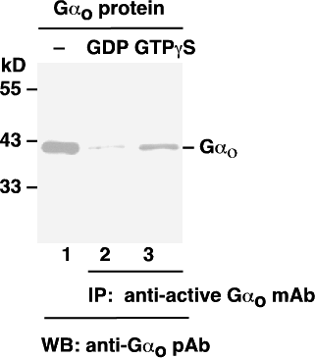

Gα_{o} activation assay. Purified Gα_{o} proteins were loaded as a control (lanes 1) or immunoprecipitated after treated with GDP (lane 2) or GTPγS (lane 3). Immunoprecipitation was done with the anti-active Gα_{o} monoclonal antibody (Cat. No. 26907). Immunoblot was with an anti-Gα_{o} polyclonal antibody (Cat. No. 21015).

