Active Sar1
Catalog Number: 26916
Gene Symbol: SAR1
Description: Anti-Active Sar1 Mouse Monoclonal Antibody

Background: Small GTPases are a super-family of cellular signaling regulators. Sar1 is a member of these small GTPases. Sar1 functions as a molecular switch to control protein–protein and protein–lipid interactions that direct vesicle budding from the ER.
Immunogen: Recombinant full length protein of active Sar1a.
Tested applications: IP, IHC

Recommended dilutions:
1 μg for 1~2 mg total cellular proteins for IP; 1:100 dilution for IHC
Concentration: 1 mg/ml
Host: mouse Clonality: Monoclonal Isotype: IgG
Purity: Purified from ascites
Format: Liquid

Storage buffer:
Preservative: no
Constituents: PBS (without Mg²⁺ and Ca²⁺), pH 7.4, 150 mM NaCl, 50% glycerol
Species Reactivity: Anti-active Sar1 antibody recognizes active Sar1 of vertebrates.
Storage Conditions: Store at -20°C. Avoid freeze / thaw cycles

Immunoprecipitation/Western blot

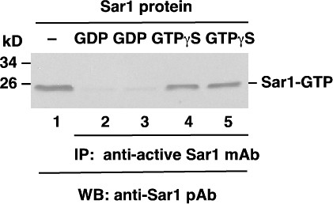

Sar1 activation assay. Purified Sar1 proteins were loaded with GDP (lanes 2 and 3) or GTP□S (lanes 4 and 5). Immunoprecipitation was done with the anti-active Sar1 monoclonal antibody (Cat. No.
26916). Immunoblot was with an anti-Sar1 rabbit polyclonal antibody (Cat. No. 21090).

