Active Gα_{s}
Catalog Number: 26906
Gene Symbol: Gnas
Description: Anti-Active Gα_{s} Mouse Monoclonal Antibody

Background: Heterotrimeric G proteins are critical cellular signal transducers. Gα_{s} represents one
sub-family of G proteins that could mediate the stimulation of adenylyl cyclases.
Immunogen: Recombinant full length protein of active Gα_{s}
Tested applications: IP, IHC

Recommended dilutions:
1 μg for 1~2 mg total cellular proteins
Concentration: 1 mg/ml
Host: mouse Clonality: Monoclonal Isotype: IgG
Purity: Purified from ascites
Format: Liquid

Storage buffer:
Preservative: no
Constituents: PBS (without Mg²⁺ and Ca²⁺), pH 7.4, 150 mM NaCl, 50% glycerol
Species Reactivity: Anti-active Gα_{s} antibody recognizes active Gα_{s} of vertebrates.
Storage Conditions: Store at -20°C. Avoid freeze /
thaw cycles

Immunoprecipitation/Western blot

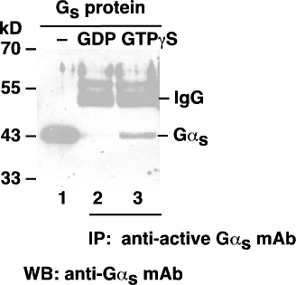

Gα_{s} activation assay. Purified Gα_{s} proteins were loaded as a control (lanes 1) or immunoprecipitated after treated with GDP (lane 2) or GTPγS (lane 3). Immunoprecipitation was done with the anti-active Gα_{s} monoclonal antibody (Cat. No. 26906).

Immunoblot was with an anti- Gα_{s} monoclonal
antibody (Cat. No. 26006).

