Active Rab11
Catalog Number: 26919

Gene Symbol: RAB11
Description: Anti-Active Rab11 Mouse Monoclonal Antibody

Background: Small GTPases of the Rab-family are crucial elements of the machinery that controls membrane traffic. Rab11 has been shown to control traffic through the recycling endosome.
Immunogen: Recombinant full length protein of active Rab11
Tested applications: IP, IHC

Recommended dilutions:
IP: 1 μg for 1~2 mg total cellular proteins IHC: 1:50~100 dilution Concentration: 1 mg/ml
Host: mouse
Clonality: Monoclonal
Isotype: IgG2a, IgG2b Purity: Purified from ascites Format: Liquid

Storage buffer:
Preservative: no
Constituents: PBS (without Mg²⁺ and Ca²⁺), pH 7.4, 150 mM NaCl, 50% glycerol
Species Reactivity: Anti-active Rab11 antibody recognizes active Rab11 from vertebrates.
Storage Conditions: Store at -20°C. Avoid freeze / thaw cycles

Immunoprecipitation and Western blot:

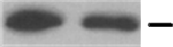



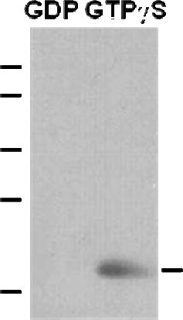

Rab11 activation assay. Purified full-length Rab11 proteins were immunoprecipitated after treated with GDP (lane left) or GTPγS (lane right). Immunoprecipitation was done with the anti-active Rab11 monoclonal antibody (Cat. No. 26919). Immunoblot was with an anti-Rab5 polyclonal antibody (Cat. No. 21157).

