Active Rab3
Catalog Number: 26920

Gene Symbol: RAB3
Description: Anti-Active Rab3 Mouse Monoclonal Antibody

Background: Rab3 is a member of the Rab-family GTPases and is specifically targeted to synaptic vesicles.
Immunogen: Recombinant full length protein of active Rab3A
Tested applications: IP, IHC, IF

Recommended dilutions:
1 μg for ~2 mg total cellular proteins for IP; 1:100 dilution for IHC, IF
Concentration: 1 mg/ml
Host: mouse Clonality: Monoclonal Isotype: IgG
Purity: Purified from ascites
Format: Liquid

Storage buffer:
Preservative: no
Constituents: PBS (without Mg²⁺ and Ca²⁺), pH 7.4, 150 mM NaCl, 50% glycerol
Species Reactivity: Anti-active Rab3 antibody recognizes active Rab3 proteins of vertebrates. Storage Conditions: Store at -20°C. Avoid freeze
/ thaw cycles

Immunoprecipitation/Western blot:

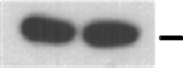





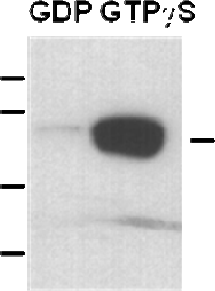
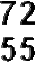

Rab3 activation assay. Purified full-length Rab3A proteins were immunoprecipitated after treated with GDP (lane 1) or GTPγS (lane 2). Immunoprecipitation was done with the anti-active Rab3 monoclonal antibody (Cat. No. 26920). Immunoblot was with an anti-Rab3A polyclonal antibody (Cat. No. 21041).

s

