Active Rab4
Catalog Number: 26921

Gene Symbol: RAB4
Description: Anti-Active Rab4 Mouse Monoclonal Antibody

Background: Rab-4 belongs to the small GTPase Rab family. It interacts with RAB11FIP1, RABEP1, ZFYVE20, RUFY1, SGSM1, SGSM2
and SGSM3. It participates in protein transport and in vesicular traffic.
Immunogen: Recombinant full length protein of active Rab4A.
Tested applications: IP, IHC

Recommended dilutions:
IP: 1 μg for 1~2 mg total cellular proteins IHC: 1:50~100
Concentration: 1 mg/ml
Host: mouse Clonality: Monoclonal Isotype: IgG
Purity: Purified from ascites
Format: Liquid

Storage buffer:
Preservative: no
Constituents: PBS (without Mg²⁺ and Ca²⁺), pH 7.4, 150 mM NaCl, 50% glycerol
Species Reactivity: Anti-active Rab4 antibody recognizes active Rab4 from vertebrates.
Storage Conditions: Store at -20°C. Avoid freeze / thaw cycles

Immunoprecipitation and Western blot:


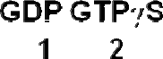

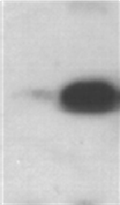
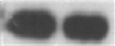




Rab4A activation assay. Purified GST-tagged Rab4A proteins (Cat. #10130) were immunoprecipitated with the anti-active Rab4 monoclonal antibody (Cat. No. 26921) after treated with GDP (lane 1) or GTPγS (lane 2), and was blotted with anti-Rab4A polyclonal antibody (Cat. No. 21067). Input control is shown in the bottom panel.

