Active Ral
Catalog Number: 26913

Gene Symbol: RAL
Description: Anti-Active Ral Mouse Monoclonal Antibody

Background: The Ras-like small G proteins, RalA and RalB, are important components of Ras signaling pathways, implicated in the initiation and maintenance of tumorigenic transformation, as well as vesicle transport, apoptosis, transcription, cell migration, and cell proliferation.
Immunogen: Recombinant full length protein of active RalB.
Tested applications: IP, IHC

Recommended dilutions:
1 μg for 1~2 mg total cellular proteins for IP; 1:100 dilution for IHC
Concentration: 1 mg/ml
Host: mouse Clonality: Monoclonal Isotype: IgG
Purity: Purified from ascites
Format: Liquid

Storage buffer:
Preservative: no
Constituents: PBS (without Mg²⁺ and Ca²⁺), pH 7.4, 150 mM NaCl, 50% glycerol
Species Reactivity: Anti-active Ral antibody recognizes active RalA and RalB of vertebrates. Storage Conditions: Store at -20°C. Avoid freeze / thaw cycles

Immunoprecipitation/Western blot

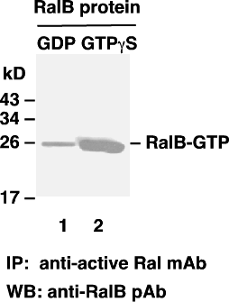

Ral activation assay. Purified RalB proteins were immunoprecipitated after treated with GDP (lane 1) or GTPγS (lane 2). Immunoprecipitation was done with the anti-active Ral monoclonal antibody (Cat. No. 26913). Immunoblot was with an anti-RalB rabbit polyclonal antibody (Cat. No. 21033).

